25.35: a) When there is no current flowing, the voltmeter reading is simply the emf of the battery: 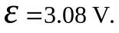
b) The voltage over the internal resistance is:
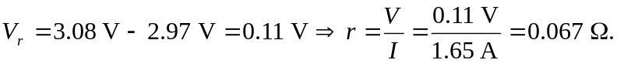
c) 